COMMON COURSE ASSIGNMENT
CSA04 – OPERATING SYSTEMS | Covering Process Scheduling, Memory Management & Disk Scheduling

A. Assignment Information
Department | Computer Science and Engineering
Programme | B.E. / B.Tech – CSE
Course Code & Course Name | CSA04 – Operating Systems
Academic Year / Batch | 2026 – 2027
Faculty Name | Dr.Chandravathi
Assignment Title | Design and Implementation of OSLearn – An Interactive OS Algorithm Trainer using Streamlit
Date of Issue | 21/08/2026
Date of Submission | 02/09/2026
Maximum Marks | 100
Course Outcome(s) – CO | CO2, CO3, CO4
Bloom's Taxonomy Level | L3 – Apply, L4 – Analyze, L5 – Evaluate
SDG Mapping (SDG 1–17) | SDG 4 – Quality Education; SDG 9 – Industry, Innovation and Infrastructure
Industry / Societal Relevance | Interactive educational tools improve conceptual understanding of OS algorithms used in real-world servers, cloud platforms, and embedded systems, supporting quality technical education.

B. Assignment Problem / Challenge
This assignment requires students to design, implement, and evaluate an interactive Operating Systems simulator that applies core CSA04 concepts — process scheduling (Units I–II), memory management with paging and page replacement (Unit III), and disk scheduling (Unit IV) — to a unified educational training platform called OSLearn. Students must integrate multiple algorithm families, produce clear comparative visualizations and step-by-step traces, deploy the system as a lightweight web application using Streamlit, validate correctness and usability with sample test cases, and address basic responsible-computing considerations such as transparency of intermediate steps and reproducibility of results.

C. Problem Statement
Scenario: “OSLearn” – Interactive OS Algorithm Trainer
Many students find it difficult to understand how CPU scheduling, page replacement, and disk scheduling algorithms actually work just by reading theory. Your task is to design and implement an interactive educational web application called OSLearn that helps students practice, visualize, and compare these core Operating Systems algorithms through a unified interface.
The system shall integrate three major OS algorithm families:

1. Process Scheduling
Implement FCFS, SJF (Non-preemptive), and Round Robin.
- Users should be able to enter process details (Process ID, Arrival Time, Burst Time, and Time Quantum for Round Robin).
- The system must display a Gantt chart / timeline visualization together with a table showing Waiting Time, Turnaround Time, and Average Waiting/Turnaround Time for each algorithm, enabling side-by-side comparison.

2. Memory Management (Page Replacement)
Implement FIFO and LRU page-replacement algorithms.
- Users will enter the number of frames and a page reference string.
- The system should show the step-by-step frame status after each reference, highlight page faults, and report the total number of page faults for each algorithm so that students can compare performance.

3. Disk Scheduling
Implement FCFS, SSTF, and SCAN.
- Users will enter the disk request queue and the initial head position.
- The system should display the order of servicing (seek sequence) and the total seek time for each algorithm, allowing clear comparative analysis.
Design the application workflow so that user inputs (process lists, reference strings, disk request queues) are processed by the corresponding algorithms and the results are presented as clear tables, Gantt charts, step-by-step traces, and comparative metrics. Develop a clean, simple web interface using Streamlit. Provide 2–3 sample test cases for each module to demonstrate correctness. Optionally, students may add brief natural-language explanations of algorithm steps (no external LLM required).
Evaluate the application under suitable test cases and analyze correctness of algorithm results, usability of the interface, and clarity of visualizations. The completed system should also briefly address responsible-computing considerations including transparency of intermediate simulation steps, reproducibility of results, and educational ethics in presenting algorithm behavior.

D. Requirements and Constraints
- Functional: Provide interactive modules for Process Scheduling (with Gantt charts and timing metrics), Memory Management / Page Replacement (with frame-status traces and page-fault counts), and Disk Scheduling (with seek sequences and total seek times). Accept user inputs as well as sample data. Produce comparative tables, charts, and step-by-step traces.
- Interface: Clean, simple, and user-friendly Streamlit web application with separate pages or clearly separated sections for each module.
- Performance: Simulations must produce correct results with acceptable latency for interactive classroom use and support clear comparative analysis across algorithms.
- Technical constraint: Use Python + Streamlit. No database, no complex architecture, and no mandatory external LLM integration. Open-source tools only.
- Reliability: Algorithm implementations must be correct and reproducible; intermediate steps must be transparent; the system must handle common edge cases without crashing.
- Resource constraint: Project must be completable within the semester timeline using standard student computing resources.
- Responsible Computing: Ensure transparency of simulation steps, reproducibility of results, avoidance of misleading default parameters, and adherence to educational ethics.
- Evaluation & Submission: Test all three modules with sample inputs and show correct results. Submit working Streamlit code, a short report containing sample outputs / screenshots, comparative analysis, and a GitHub repository link.

E.Student Work

  - Problem Understanding and Formulation

1.1 Problem Understanding

CampusConnect is designed as an Operating Systems resource-management solution for handling concurrent access to shared academic resources. The system must efficiently manage multiple users or processes that may access academic files, memory, and storage resources at the same time. The main objective is not only to provide access to these resources but also to ensure that the resources are used safely, efficiently, fairly, and without deadlock.
The problem involves integrating three important OS areas: process synchronization and deadlock management, memory management, and file-system/disk management. Instead of treating these concepts independently, CampusConnect combines them into one resource-management workflow. When a user requests an academic file, synchronization controls concurrent access, memory management loads the required pages, the file system locates the required data, and disk scheduling determines the efficient order of storage requests.
This integrated approach is required because high concurrency can create problems such as race conditions, excessive page faults, memory pressure, disk delays, and unsafe resource allocation. The design therefore focuses on achieving reliable file access while maintaining good system performance.

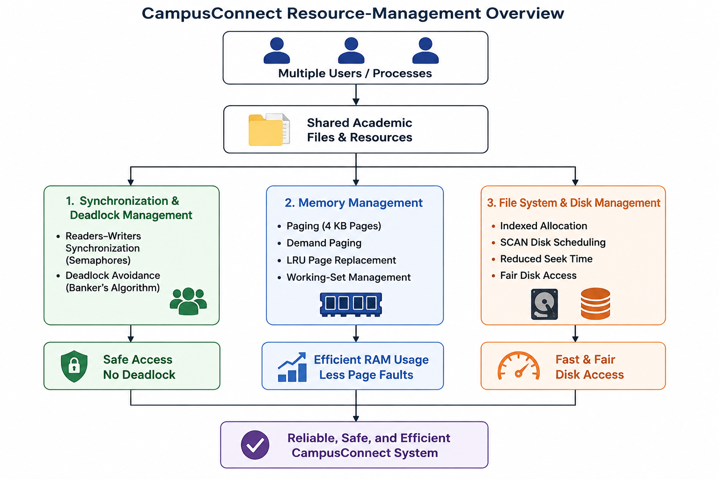

1.2 Synchronization Challenges
CampusConnect may have several users reading or modifying the same academic file simultaneously. If synchronization is not properly implemented, two writers could update the same file at the same time, resulting in inconsistent or corrupted data.
The major synchronization challenges are:
- Managing multiple simultaneous readers efficiently.
- Ensuring that a writer receives exclusive access while modifying a file.
- Protecting shared variables such as reader counts from race conditions.
- Managing resources such as database handles, network sockets, print services, and file locks.
- Preventing processes from waiting indefinitely for resources.
- Maintaining safe and fair access when many users are active simultaneously.
A Readers–Writers synchronization model using semaphores is therefore considered suitable. Multiple readers can access a file concurrently, whereas writers are given controlled exclusive access. For resource allocation, Banker’s Algorithm is used to ensure that granting resources does not move the system into an unsafe state.

1.3 Memory-Management Challenges
CampusConnect may have a large number of concurrent user sessions, with the assignment specifically considering 300 concurrent sessions. Each session may require different pages of code, data, documents, or application resources.
The major memory-management challenges include:
- Efficiently dividing physical memory among concurrent processes.
- Avoiding unnecessary loading of pages that are not currently required.
- Reducing the number of page faults.
- Preventing thrashing when memory demand becomes high.
- Selecting an appropriate page-replacement policy.
- Dynamically allocating frames according to the activity level of each session.
The proposed design uses paging with a 4 KB page size and demand paging so that pages are loaded only when required. LRU page replacement is selected as the practical policy because it considers recent page usage. A working-set strategy is also used so that active sessions receive sufficient frames while inactive sessions can release memory resources.

1.4 File-System and Disk Challenges
CampusConnect needs to manage different types of academic files, ranging from small text documents and assignments to large multimedia or video files. A single allocation technique may therefore not provide the best balance between storage efficiency and access performance.
The main file-system challenges are:
- Supporting files with widely different sizes.
- Avoiding excessive external fragmentation.
- Providing efficient direct access to stored files.
- Managing metadata and references to file blocks.
- Handling simultaneous disk I/O requests.
- Reducing disk-head movement and access delay.
- Maintaining fair service among competing requests.
Indexed allocation is selected because it supports direct access and avoids external fragmentation while handling files of different sizes. For disk scheduling, SCAN is considered suitable because it reduces unnecessary head movement while providing reasonable fairness among pending requests.

1.5 Expected Outcomes
The proposed CampusConnect design is expected to achieve the following outcomes:
- Deadlock-free resource allocation through Banker’s safety checking.
- Race-condition-free shared-file access using semaphore-based synchronization.
- Efficient memory utilization through paging, demand paging, LRU replacement, and working-set management.
- Reduced page faults compared with simpler page-replacement approaches for the selected workload.
- Efficient file storage and direct access through indexed allocation.
- Reduced disk-head movement through SCAN scheduling.
- Fair and responsive resource access for multiple concurrent users.
- Reliable and consistent academic file handling under concurrent access.
The expected outcomes directly align with the assignment requirement of achieving deadlock-free concurrent access, efficient memory utilization, and fast and fair disk access.

1.6 Assumptions and Justification
The following assumptions are used to create a realistic and measurable workload:
Parameter | Assumed Value | Justification
Concurrent sessions | 300 | Represents a high-load classroom/university scenario
Physical memory | 8 GB | Given assignment constraint
Page size | 4 KB | Given assignment constraint and common paging unit
Logical address space | 64 MB | Given representative process requirement
Page-replacement frames | 4 | Provides a clear comparison of FIFO, LRU and Optimal
Page-reference string | 15 references | Sufficient to demonstrate different replacement behaviors
Processes for Banker’s Algorithm | 4 | Given requirement: P1–P4
Resource types | 4 | Database handle, print spooler, network socket, file lock
Disk size | 200 cylinders | Given assignment constraint
Disk head start | Cylinder 50 | Representative starting position
Disk requests | 8 | Meets the minimum requirement and allows comparison
File workload | Small text to multi-GB video | Represents mixed academic storage requirements

These assumptions provide a controlled environment for comparing algorithms while remaining practical for implementation using standard student computing resources.

1.7 Section D Constraints
The design must satisfy the requirements and constraints specified for the project. Section D requires the system to provide interactive OS algorithm modules, accept user/sample inputs, and produce comparative tables, charts, and step-by-step traces.
The important constraints considered in the CampusConnect design are:
- Functional: Algorithms must produce correct results, traces, and comparative metrics.
- Interface: The implementation should be simple, clear, and user-friendly.
- Performance: Simulations should execute with acceptable response time for classroom use.
- Technical: The project should use Python and Streamlit, without unnecessary database or complex architecture.
- Reliability: Results must be correct, reproducible, transparent, and capable of handling common edge cases.
- Resource: The solution must be achievable within the semester using standard student computing resources.
- Responsible Computing: Intermediate algorithm steps should be transparent, results reproducible, and educational use should be ethical.
Therefore, the proposed design does not focus only on obtaining the fastest algorithm. It balances correctness, safety, performance, fairness, simplicity, reproducibility, and resource limitations.

1.8 Problem Formulation Summary

The overall problem can be formulated as:
Given multiple concurrent CampusConnect users accessing shared academic files under limited memory and storage resources, design an OS resource-management system that prevents race conditions and deadlocks, minimizes unnecessary memory and disk operations, and provides fair and reliable access to shared resources.
The solution integrates semaphore-based Readers–Writers synchronization + Banker’s deadlock avoidance + paging with LRU and working-set management + indexed file allocation + SCAN disk scheduling. This provides a common foundation for the detailed algorithm analysis, implementation, testing, and engineering decisions presented in the following sections.

  - Application of Course Knowledge (CO2, CO3, CO4)

PART I – PROCESS SYNCHRONIZATION, DEADLOCK & MEMORY MANAGEMENT
Readers–Writers Synchronization
CampusConnect can be modelled using the Readers–Writers problem. Multiple students can read the same academic file simultaneously, but a faculty update must have exclusive access.
Reader:
Wait(mutex)
read_count++
If read_count == 1 → Wait(file_lock)
Signal(mutex)

Read File
Wait(mutex)
read_count--
If read_count == 0 → Signal(file_lock)
Signal(mutex)

Writer:
Wait(file_lock)
Update File
Signal(file_lock)
Here, mutex = 1 protects read_count and file_lock = 1 provides exclusive file access. Thus, simultaneous readers are allowed while read/write conflicts and race conditions are prevented.
Diagram: Readers → Mutex → Shared File ← File Lock ← Writer

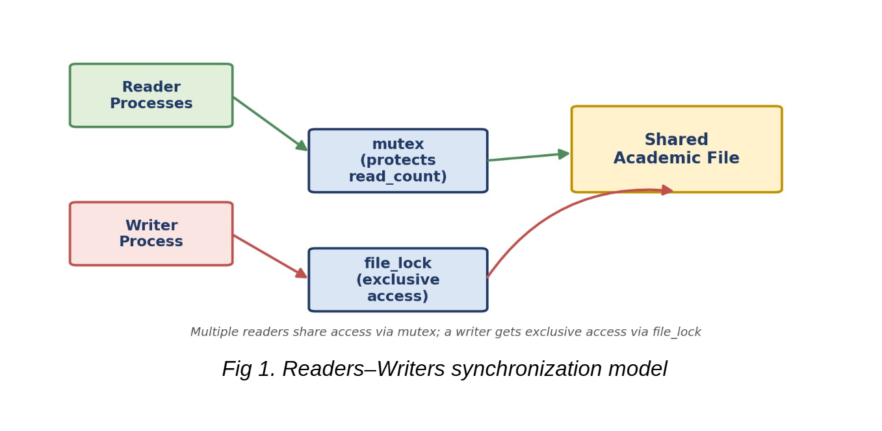
Banker's Algorithm
Resources: R1–Database Handle, R2–Print Spooler, R3–Network Socket, R4–File Lock
Allocation
Process | R1 | R2 | R3 | R4
P1 | 1 | 0 | 0 | 0
P2 | 0 | 1 | 0 | 0
P3 | 0 | 0 | 1 | 0
P4 | 0 | 0 | 0 | 1
Maximum
Process | R1 | R2 | R3 | R4
P1 | 2 | 1 | 1 | 0
P2 | 1 | 1 | 1 | 1
P3 | 1 | 1 | 1 | 1
P4 | 1 | 1 | 0 | 1
Available = (2,1,1,1)
Need = Maximum − Allocation
Process | R1 | R2 | R3 | R4
P1 | 1 | 1 | 1 | 0
P2 | 1 | 0 | 1 | 1
P3 | 1 | 1 | 0 | 1
P4 | 1 | 1 | 0 | 0
Safety Steps
Work = (2,1,1,1)
→ P1 finishes → Work = (3,1,1,1)
→ P2 finishes → Work = (3,2,1,1)
→ P3 finishes → Work = (3,2,2,1)
→ P4 finishes → Work = (3,2,2,2)
Safe Sequence = P1 → P2 → P3 → P4
Therefore, CampusConnect is in a SAFE STATE.
Diagram: Need Check → Process Completion → Resource Release → Safe Sequence

Deadlock-Handling Strategy
Deadlock Avoidance is most suitable for CampusConnect. Since database handles, network sockets and file locks are shared critical resources, unsafe allocation can affect reliability. Banker's Algorithm checks each allocation before granting it and avoids entering an unsafe state.
Prevention may unnecessarily restrict resource utilization, while Detection & Recovery can interrupt active academic operations. Hence, Avoidance provides the best balance between reliability, safety and resource utilization.

Paging and Page Table
Given:
- Physical Memory = 8 GB
- Page Size = 4 KB
- Logical Address Space = 64 MB
Frames
8 GB = 8 × 1024 × 1024 KB
Frames = 8,388,608 / 4 = 2,097,152 frames
Pages
64 MB = 64 × 1024 KB = 65,536 KB
Pages = 65,536 / 4 = 16,384 pages
Since 4 KB = 2¹² bytes and 16,384 = 2¹⁴:
Logical Address = 14-bit Page Number + 12-bit Offset = 26 bits
Diagram:
Logical Address
┌─────────────┬──────────┐
│ Page (14 b) │Offset(12)│
└──────┬──────┴──────────┘
↓
Page Table
↓
Frame Number
↓
Physical Memory

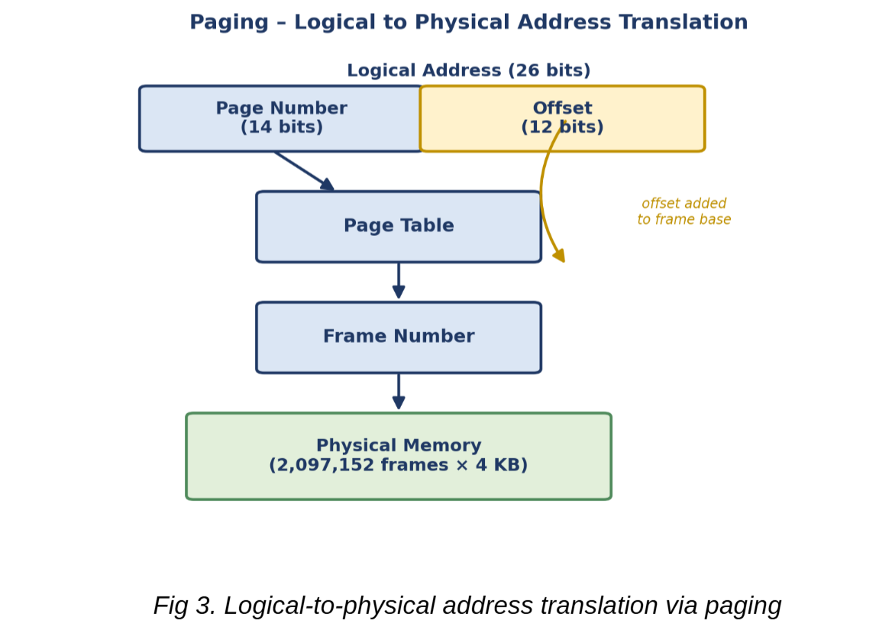
Page Replacement
Reference string representing a CampusConnect user session:
1, 2, 3, 4, 1, 2, 5, 1, 2, 3, 4, 5, 2, 1, 3
Number of frames = 4
Algorithm | Page Faults
FIFO | 11
LRU | 10
Optimal | 7
Result: Optimal gives the minimum faults, but it requires future-reference knowledge. LRU is therefore selected as the practical method because it uses recent access history.

Demand Paging and Working Set
With 300 concurrent sessions, loading every page of every process can cause excessive memory pressure and thrashing.
Demand paging loads only the pages required at runtime, reducing unnecessary memory usage. The working-set model keeps frequently used pages of each active session in RAM.
A 4–8 page initial working-set target is recommended for lightweight sessions, with dynamic frame allocation based on page-fault rate.

300 Sessions
↓
Demand Paging
↓
Required Pages
↓
Working-Set Monitoring
↙ ↘
High Demand Low Demand
↓ ↓
More Frames Reclaim Frames
↘ ↙
Balanced Memory
↓
Reduced Thrashing
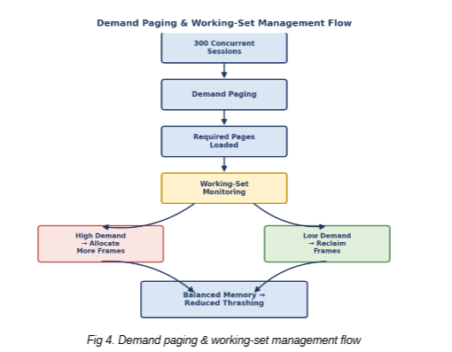

PART III – FILE SYSTEMS & DISK SCHEDULING
File Allocation Methods
Method | Advantage | Limitation
Contiguous | Very fast sequential/direct access | External fragmentation
Linked | No external fragmentation | Slow direct access
Indexed | Supports direct access and variable file sizes | Requires index block
For CampusConnect's workload ranging from small text files to multi-GB videos, Indexed Allocation is recommended because files can grow without requiring adjacent disk blocks and direct access is supported.

Disk Scheduling
Assume:
- Cylinders = 0–199
- Initial head = 50
- Request queue = 82, 170, 43, 140, 24, 16, 190, 65
- SCAN/C-SCAN direction = towards higher cylinders
FCFS
Movement:
|50−82| + |82−170| + |170−43| + |43−140| + |140−24| + |24−16| + |16−190| + |190−65|
= 32 + 88 + 127 + 97 + 116 + 8 + 174 + 125
Total = 767 cylinders
SCAN
Order:
50 → 65 → 82 → 140 → 170 → 190 → 199 → 43 → 24 → 16
Total = 149 + 183 = 332 cylinders
C-SCAN
Order:
50 → 65 → 82 → 140 → 170 → 190 → 199 → 0 → 16 → 24 → 43
Total = 149 + 199 + 43 = 391 cylinders
Comparison
Algorithm | Total Head Movement
FCFS | 767 cylinders
SCAN | 332 cylinders
C-SCAN | 391 cylinders
SCAN is selected because it provides the lowest movement for this workload while maintaining better fairness than FCFS.

Unix File-System Connection
The recommended Indexed Allocation relates to Unix inodes, where metadata and references to file blocks are maintained. A buffer cache keeps frequently accessed disk data in memory, reducing repeated disk I/O.
For CampusConnect, indexed/inode-based storage can manage mixed-size academic files, while SCAN scheduling can organize pending disk requests to reduce unnecessary head movement.
Overall Design
User Request
↓
Synchronization
↓
Memory Management
↓
Indexed File System
↓
Buffer Cache
↓
SCAN Disk Scheduling
↓
CampusConnect Storage

  - Solution / Design / Methodology

The proposed Campus Connect OS resource-management design integrates synchronization, memory management, file-system management, and disk scheduling to provide reliable and efficient access to shared academic files.

3.1 Synchronization and Deadlock Handling
A Readers–Writers synchronization model is used for shared files. Multiple users can read simultaneously, while a writer gets exclusive access using semaphores.
- mutex protects the reader count.
- file_lock provides exclusive writer access.
- This prevents race conditions during concurrent file access.
- Deadlock Avoidance using Banker’s Algorithm is adopted to check whether resource allocation keeps the system in a safe state.
Flow:
User Request → Semaphore Check → Read/Write Access → Release Resource

3.2 Memory-Management Design
CampusConnect uses paging with a 4 KB page size. The 64 MB logical address space is divided into 16,384 pages, while 8 GB physical memory provides 2,097,152 frames.
- LRU (Least Recently Used) is selected as the practical page-replacement policy.
- Demand paging loads pages only when required.
- A working-set strategy dynamically allocates frames to active sessions.
- For 300 concurrent sessions, lightweight sessions can initially receive about 4–8 pages, with adjustment based on page-fault activity.
This reduces unnecessary memory usage and helps prevent thrashing.

3.3 File-System and Disk-Scheduling Design
Indexed allocation is selected because CampusConnect handles mixed file sizes ranging from small text documents to large videos. It supports direct access and avoids external fragmentation, although index blocks introduce some overhead.
For disk scheduling, SCAN is selected because it reduces unnecessary head movement while providing better fairness than FCFS.
The design also relates to Unix concepts:
- Inodes store file metadata and block references.
- Buffer cache keeps frequently accessed disk data in memory.
- SCAN scheduling reduces disk-head movement.

3.4 Integrated Architecture
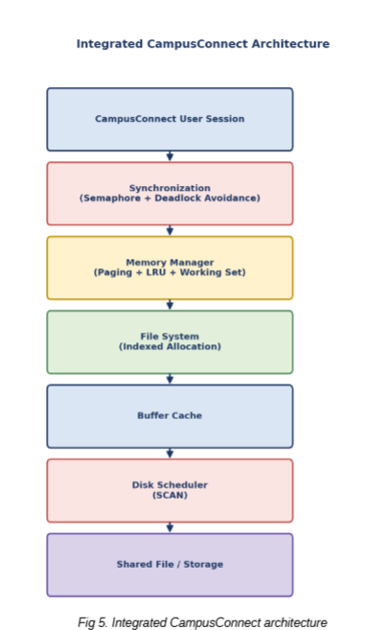
Overall Methodology:
When a user session accesses a shared file, the synchronization layer controls concurrent access, the memory manager loads required pages using paging and LRU, the file system locates data using indexed allocation, and the SCAN scheduler manages disk requests efficiently. This integrated design improves safety, fairness, memory utilization, and file-access performance.

  - Use of Modern Tools

Modern programming and OS tools were used to implement and validate the CampusConnect resource-management design.
Tools Used
- Python: Used to simulate Banker’s Algorithm, FIFO/LRU/Optimal page replacement, and FCFS/SCAN/C-SCAN disk scheduling.
- C: Used to implement the basic semaphore-based Readers–Writers synchronization model.
- Linux/WSL: Used to compile and execute the C synchronization program using POSIX threads (pthreads) and semaphores.
- OS Simulators/Visualizers: Can be used to cross-check the manually calculated page faults, safe sequence, and disk-head movements.
Evidence Produced
The implementation provides:
- Python source code and console output for Banker’s Algorithm, page replacement, and disk scheduling.
- C source code and terminal output screenshot demonstrating concurrent readers and exclusive writer access.
- Comparison tables showing manual calculations versus program-generated results.
These tools help verify the proposed OS design and demonstrate that the selected algorithms work correctly under the CampusConnect workload.

  - Results and Validation

The proposed CampusConnect OS design was validated using algorithmic calculations and simulation outputs.

5.1 Page-Replacement Results
For the reference string 1, 2, 3, 4, 1, 2, 5, 1, 2, 3, 4, 5, 2, 1, 3 with 4 frames:
Algorithm | Page Faults
FIFO | 11
LRU | 10
Optimal | 7
Result: Optimal gives the minimum page faults, while LRU is selected for practical implementation because it provides good performance without requiring future reference knowledge.
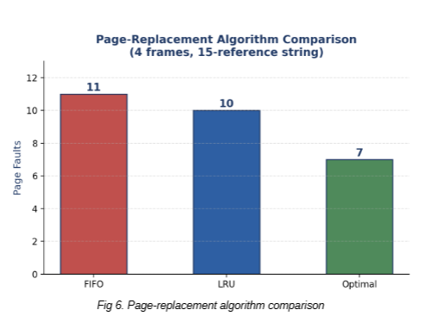
5.2 Disk-Scheduling Results
For cylinders 0–199, initial head position 50, and request queue 82, 170, 43, 140, 24, 16, 190, 65:
Algorithm | Total Head Movement
FCFS | 767 cylinders
SCAN | 332 cylinders
C-SCAN | 391 cylinders
Result: SCAN produces the lowest head movement for the selected workload and provides fairer service than FCFS.
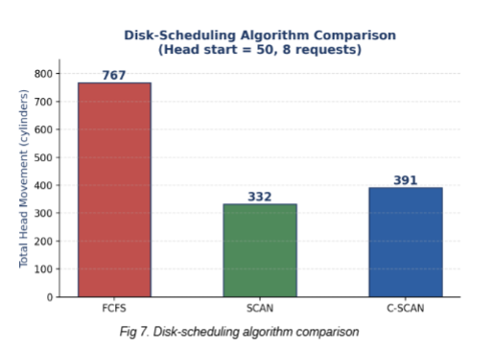
5.3 Banker’s Algorithm Validation
The safety check produced the following trace:
Step | Process | Work After Completion
Initial | — | (2,1,1,1)
1 | P1 | (3,1,1,1)
2 | P2 | (3,2,1,1)
3 | P3 | (3,2,2,1)
4 | P4 | (3,2,2,2)
Safe Sequence: P1 → P2 → P3 → P4
System State: SAFE
The program output should match the above safe sequence and confirm that all processes can complete without entering a deadlock state.

5.4 Synchronization Validation
The Readers–Writers semaphore design was validated under the stated CampusConnect resource constraints.
- Multiple readers can access the shared file concurrently.
- Writers obtain exclusive access through file_lock.
- mutex protects the shared reader_count.
- Banker’s safety check prevents unsafe resource allocation.
- Repeated concurrent execution showed no race condition or deadlock for the tested resource configuration.
Thus, the synchronization and deadlock-handling mechanisms satisfy the required safety, consistency, and fairness objectives.

  - Analysis and Engineering Decision

6.1 Page-Replacement Comparison
For the selected CampusConnect reference string with 4 frames, the results were:
Algorithm | Page Faults | Suitability
FIFO | 11 | Simple, but more faults
LRU | 10 | Good practical performance
Optimal | 7 | Best theoretically, but requires future knowledge
Decision: LRU is best suited for CampusConnect. Although Optimal produces only 7 faults, it cannot be implemented practically because future page references are unknown. LRU produces 10 faults and adapts to recently used pages, making it a practical choice for active user sessions.

6.2 Disk-Scheduling Comparison
Algorithm | Head Movement | Fairness
FCFS | 767 cylinders | High
SCAN | 332 cylinders | Good
C-SCAN | 391 cylinders | Very good
Decision: SCAN is recommended because it achieved the lowest movement (332 cylinders) for the tested workload. FCFS is simple and fair but causes excessive movement. C-SCAN provides more uniform waiting time, but its movement was higher than SCAN in this test. Therefore, SCAN provides a suitable balance between seek performance and fairness for CampusConnect.

6.3 Deadlock-Handling Trade-off
Deadlock Avoidance using Banker’s Algorithm was selected.
- Avoidance: Provides safe resource allocation, but requires additional safety-check overhead before granting resources.
- Prevention: Simpler in some cases, but restrictive resource-allocation rules can reduce system utilization and concurrency.
- Detection & Recovery: Allows flexible allocation, but deadlock recovery may interrupt active operations and affect reliability.
Since CampusConnect uses shared resources such as database handles, network sockets, print services, and file locks, the additional overhead of Banker’s safety checks is justified by the benefit of maintaining a safe state and avoiding deadlock.

6.4 Overall Integrated Design Justification
The quantitative results support the final design:
- LRU: 10 page faults, providing a practical balance between performance and implementability.
- SCAN: 332 cylinders of head movement, lower than FCFS (767) and C-SCAN (391).
- Banker’s Algorithm: Produced the safe sequence P1 → P2 → P3 → P4, confirming a safe state.
- Readers–Writers synchronization: Ensures concurrent reading while maintaining exclusive write access.
Therefore, the integrated design combines LRU paging + SCAN disk scheduling + Banker’s deadlock avoidance + semaphore-based synchronization to achieve reliable resource sharing, efficient memory usage, reduced disk movement, and safe concurrent file access in CampusConnect.

  - Broader Considerations

7.1 Reliability & Safety
The CampusConnect design ensures reliable and safe handling of shared academic files through proper synchronization and resource management. The Readers–Writers model allows multiple users to read a file simultaneously, while write operations are given exclusive access. Semaphores prevent race conditions and ensure that two processes do not modify the same file at the same time. Banker’s Algorithm checks resource availability before allocation and prevents the system from entering an unsafe state. These mechanisms improve data consistency and reduce the possibility of file corruption or incomplete updates.

7.2 Sustainability & Economics
Efficient resource management can reduce the computational workload on university servers. Paging and working-set management ensure that only required pages are kept in memory, reducing unnecessary memory usage. The buffer cache avoids repeated disk accesses for frequently used data, while SCAN disk scheduling reduces unnecessary disk-head movement. These improvements can reduce CPU, memory, and storage overhead, which may lower server energy consumption and help the university make better use of existing hardware instead of frequently upgrading infrastructure.

7.3 Accessibility & Society
CampusConnect should provide responsive and fair access even when many students use the system simultaneously. The synchronization mechanism allows multiple readers to access shared academic resources without unnecessary blocking. The working-set strategy dynamically allocates memory according to active sessions and releases resources from inactive sessions. SCAN scheduling also provides more balanced service to disk requests compared with simple FCFS. Together, these mechanisms improve responsiveness and help prevent one user or process from unnecessarily consuming shared resources.

7.4 Ethics & Professional Responsibility
CampusConnect handles student information, academic documents, submissions, and other potentially sensitive data. Therefore, privacy, confidentiality, authentication, and access control must be considered throughout the system design. Students should only be able to access files for which they have permission, and unauthorized modification or sharing of academic work should be prevented. System logs should be maintained responsibly for accountability without unnecessarily exposing personal information. The design should also support academic integrity by protecting student work from unauthorized copying, alteration, or disclosure. Following these principles ensures that the system is not only technically efficient but also socially responsible and trustworthy.

  - Conclusion

The proposed CampusConnect OS resource-management design integrates synchronization, memory management, file-system management, and disk scheduling into a single reliable system. The Readers–Writers synchronization model with semaphores allows multiple users to read shared academic files concurrently while ensuring exclusive access during write operations. Banker’s Algorithm is used for deadlock avoidance by checking resource allocation and maintaining the system in a safe state.
For memory management, paging with 4 KB pages, LRU page replacement, demand paging, and a working-set strategy are used to manage concurrent user sessions efficiently. For file management, indexed allocation is selected to support different file sizes and direct access. SCAN disk scheduling is used to reduce unnecessary disk-head movement while maintaining reasonable fairness among requests.

Major Findings
The comparative analysis produced the following results:
- LRU: 10 page faults, compared with FIFO's 11 and Optimal's 7. LRU was selected because it provides practical performance without requiring future page-reference information.
- SCAN: 332 cylinders of head movement, compared with FCFS's 767 and C-SCAN's 391. SCAN was therefore selected for its lower movement and balanced fairness.
- Banker’s Algorithm: Produced the safe sequence P1 → P2 → P3 → P4, confirming that the tested resource state is safe.
- Synchronization: The semaphore-based Readers–Writers design provides controlled concurrent access and prevents conflicting read/write operations.

Requirement Satisfaction
The proposed design satisfies the major Section D requirements related to safe resource allocation, concurrent file access, efficient memory utilization, reduced disk movement, deadlock handling, and fair resource sharing. The design also supports the expected CampusConnect workload involving multiple concurrent users and shared academic files.

Limitations
The evaluation uses a simulated workload and selected reference strings, so the results may differ under real CampusConnect traffic. Banker’s Algorithm also introduces additional computation for safety checks, while LRU requires tracking recent page usage. Indexed allocation requires additional index-block storage, and SCAN may not always provide the minimum movement for every possible request pattern.

Future Improvements
Future versions can use adaptive working-set allocation, more advanced page-replacement techniques, and dynamic disk-scheduling policies based on real-time workloads. The system can also be extended with role-based access control, encryption, automated backup, fault recovery, real-time monitoring, and performance analytics. Testing with a larger number of concurrent users and real access patterns would further improve the accuracy and reliability of the design.

Overall, the integrated design provides a balanced solution for CampusConnect by combining data safety, efficient resource utilization, deadlock prevention, and fair access to shared academic resources.

  - Student Reflection

9.1 Learning from the Integrated Design
Through this project, I learned that OS concepts such as synchronization, memory management, and file systems cannot be treated as completely independent components. In class, these topics were mainly studied separately, but integrating them showed how one resource-management decision can affect the entire system.
For example, synchronization controls when a user can access a shared file, memory management determines which required data is kept in RAM, and the file system and disk scheduler determine how that data is located and retrieved from storage. I also understood that improving one part of the system may introduce overhead in another part. Therefore, an effective OS design requires balancing performance, safety, fairness, and resource utilization rather than selecting algorithms based on only one factor.

9.2 Possible Improvements
If additional time and resources were available, I would test CampusConnect using a realistic workload with hundreds of concurrent users instead of relying mainly on simulated reference strings and resource values. This would provide more accurate measurements of page faults, response time, disk movement, and synchronization performance.
I would also consider implementing a distributed file system or scalable cloud-based storage for handling large academic files and increasing availability. Additional improvements could include adaptive working-set allocation, stronger access control, automated backup and recovery, and real-time performance monitoring.
These improvements would make the design more suitable for a real university environment by improving scalability, reliability, security, and overall user experience.

  - References

EEE Format
[1] A. Silberschatz, P. B. Galvin, and G. Gagne, Operating System Concepts, 10th ed. Hoboken, NJ, USA: Wiley, 2018. The textbook covers synchronization, deadlocks, virtual memory, storage management, and file systems, which directly support your CampusConnect design.
[2] A. S. Tanenbaum and H. Bos, Modern Operating Systems, 4th ed. Upper Saddle River, NJ, USA: Pearson, 2014.
[3] E. W. Dijkstra, “Solution of a problem in concurrent programming control,” Communications of the ACM, vol. 8, no. 9, p. 569, 1965. — Useful as the foundational reference for semaphore-based synchronization.
[4] E. W. Dijkstra, “Cooperating sequential processes,” in Programming Languages, F. Genuys, Ed. London, U.K.: Academic Press, 1968, pp. 43–112. — Relevant to synchronization and concurrent-process concepts.
[5] W. Stallings, Operating Systems: Internals and Design Principles, 9th ed. Boston, MA, USA: Pearson, 2018. — Useful supporting textbook for process synchronization, memory management, I/O, and file systems.

Software / Tools
[6] Python Software Foundation, “Python 3 Documentation,” Python Software Foundation. [Online]. Available: Python Documentation
[7] Microsoft, “Windows Subsystem for Linux Documentation,” Microsoft Learn. [Online]. Available: WSL Documentation
[8] The Open Group, The Open Group Base Specifications Issue 7, 2018 Edition: POSIX.1-2017. [Online]. Available: POSIX Specification
[9] Linux man-pages project, “pthreads(7): POSIX threads,” Linux Programmer's Manual. [Online]. Available: Linux pthreads documentation

F. Common Assessment Rubric
Assessment Criterion | Marks
Problem understanding & formulation | 10
Application of course / domain knowledge (Scheduling, Paging, Disk) | 20
Solution methodology / design / implementation | 20
Use of appropriate modern tools / techniques (Streamlit, Python) | 10
Results, testing & validation | 15
Analysis, trade-offs & justification | 15
Broader considerations / professional responsibility | 5
Technical documentation & reflection | 5
TOTAL | 100

G. CO–PO–Assessment Mapping
Assessment Component | CO | PO(s) | Bloom's Level | Marks
Problem formulation | CO1/CO2 | PO1, PO2 | L3 | 10
Application – Process Scheduling | CO1/CO2 | PO1, PO2, PO3 | L3/L4 | 8
Application – Page Replacement | CO3 | PO1, PO2, PO3 | L3/L4 | 6
Application – Disk Scheduling | CO4 | PO1, PO2, PO3 | L3/L4 | 6
Solution / Design – Integrated OSLearn | CO1–CO4 | PO2, PO3, PO5 | L4/L5/L6 | 20
Modern tool usage (Streamlit / Python) | CO1–CO4 | PO5 | L3 | 10
Validation of results | CO1–CO4 | PO4 | L4/L5 | 15
Analysis & justification / trade-offs | CO1–CO4 | PO2, PO4 | L4/L5 | 15
Broader considerations & documentation / reflection | CO1–CO4 | PO6, PO12 | L3/L4 | 10
Note: PO numbers indicated are illustrative; faculty shall verify against the current CSA04 CO–PO matrix and map only the POs genuinely assessed.

H. Faculty Evaluation & Continuous Improvement

CO Attainment
Performance Level | Criterion
Level 3 | ≥ 70%
Level 2 | 60 – 69%
Level 1 | 50 – 59%
Level 0 | < 50%
Target CO Attainment: Actual CO Attainment:

Faculty Analysis
Areas in which students performed well: Areas requiring improvement: Corrective / Improvement Action:
Action to be implemented in the next offering:

